**DAY 3 - API INTEGRATION AND DATA MIGRATION**

On this day, we learned how to integrate APIs for smooth communication between different systems. We also explored data migration techniques to ensure accurate and efficient data transfer while maintaining consistency.

I have attached a screenshot showing that a new project has been created on Sanity.

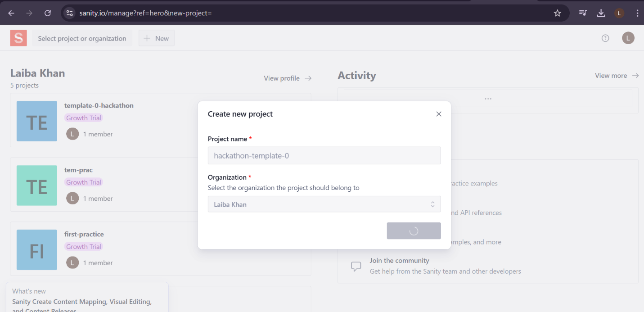

**Create project,**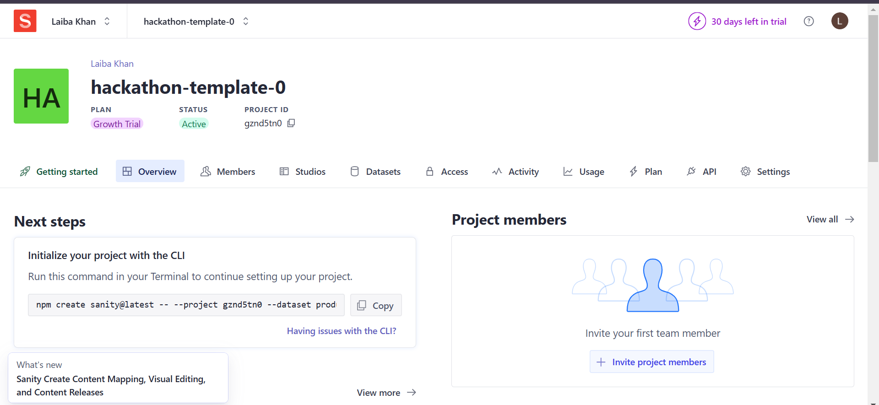

Here’s how you can describe it:

"I have set up Sanity in my Next.js 15 and React 19 project. Sanity is a headless CMS that I used for content management. Here’s what I did:

1. Logged into Sanity and created a new project.
2. Chose TypeScript and embedded Sanity Studio at the /studio route.
3. Selected a clean project template without predefined schema types.
4. Added the project ID and dataset to my .env.local file.
5. Installed dependencies such as @sanity/vision@3, sanity@3, @sanity/image-url@1, and styled-components@6.
6. Configured CORS for local development.
7. A compatibility warning appeared for Next.js 15 and React 19, with a link for more details.

(Screenshot attached showing the setup process.)"

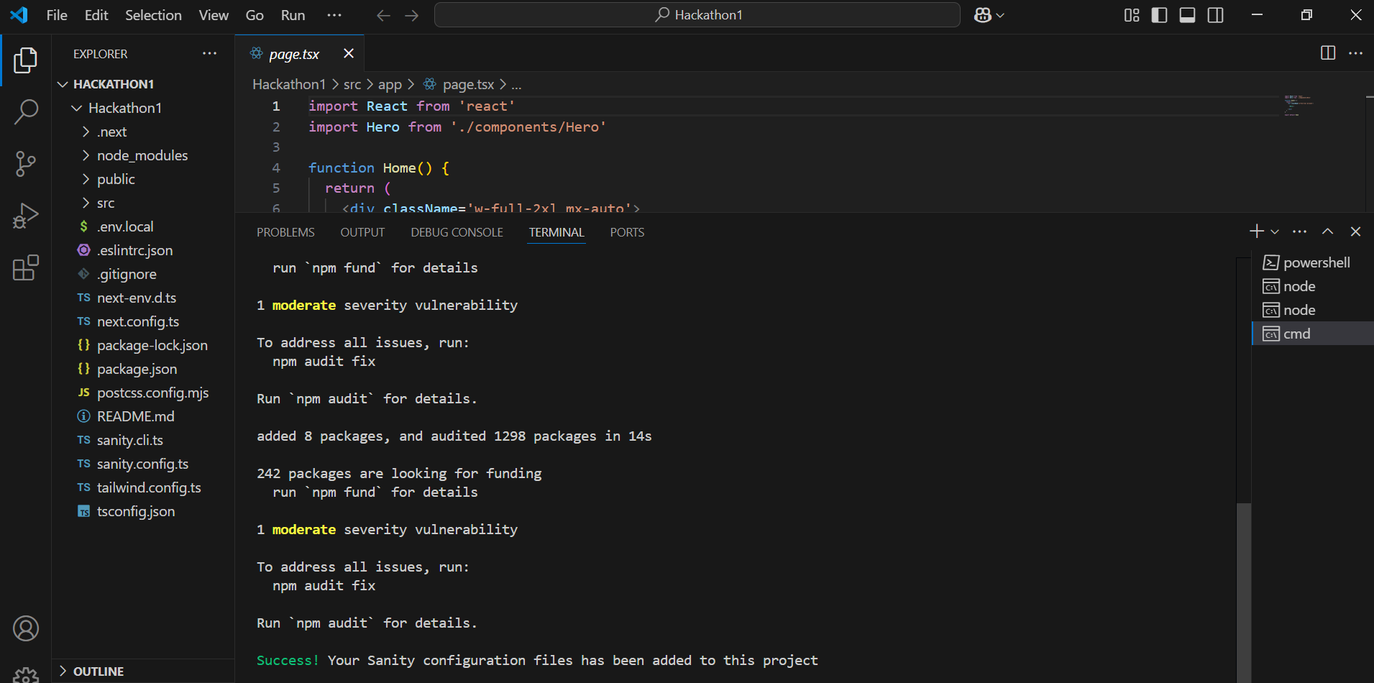

**To generate a token in Sanity,**

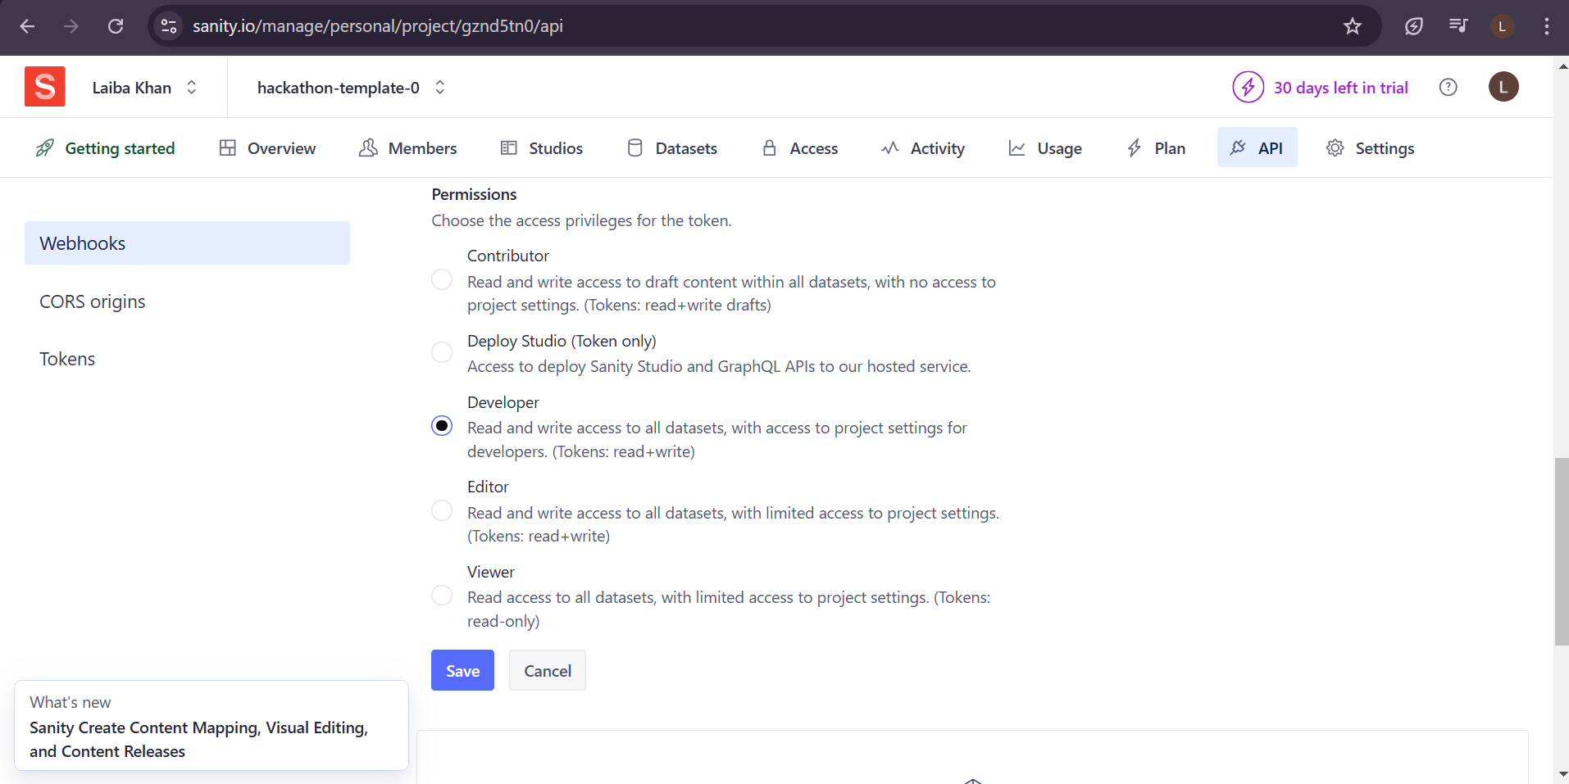

The token has been added to the .env.local file as an environment variable, allowing secure access to the Sanity API. The format is:

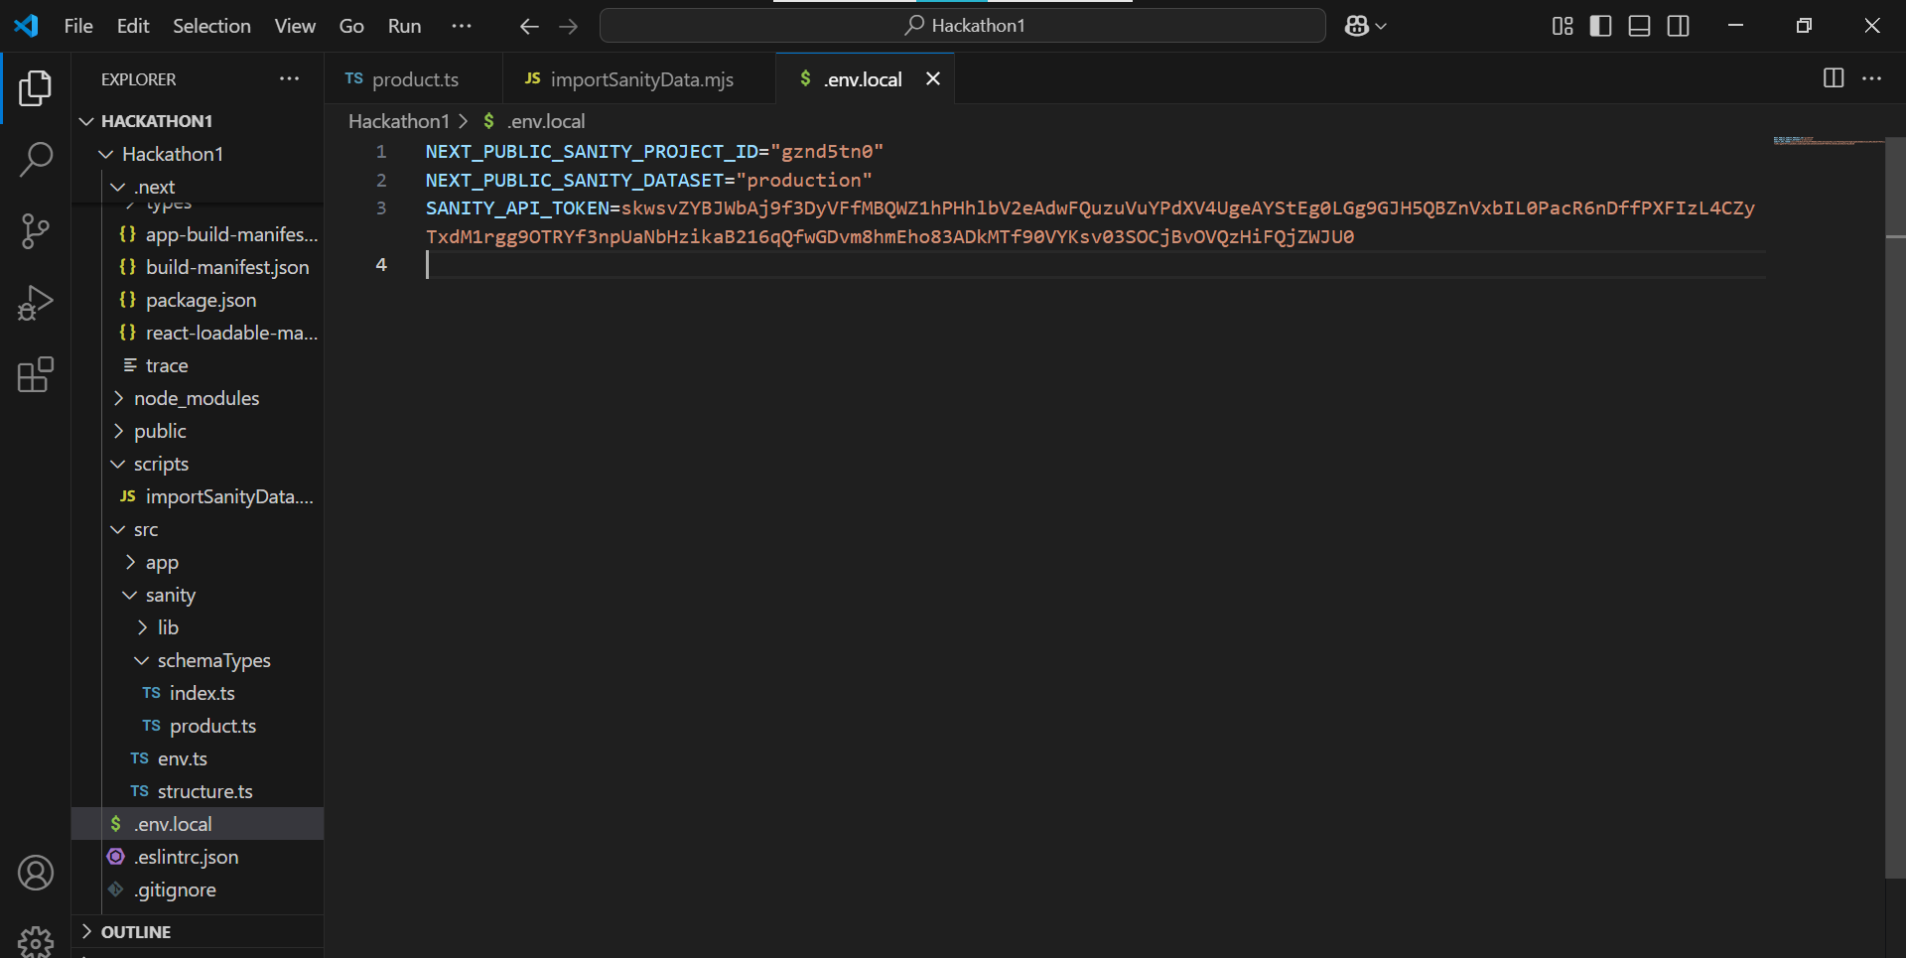

I have created a "product.js" file in the schemaTypes folder. This file defines the structure and fields for product data in Sanity, and I have pasted the provided data into the product file.

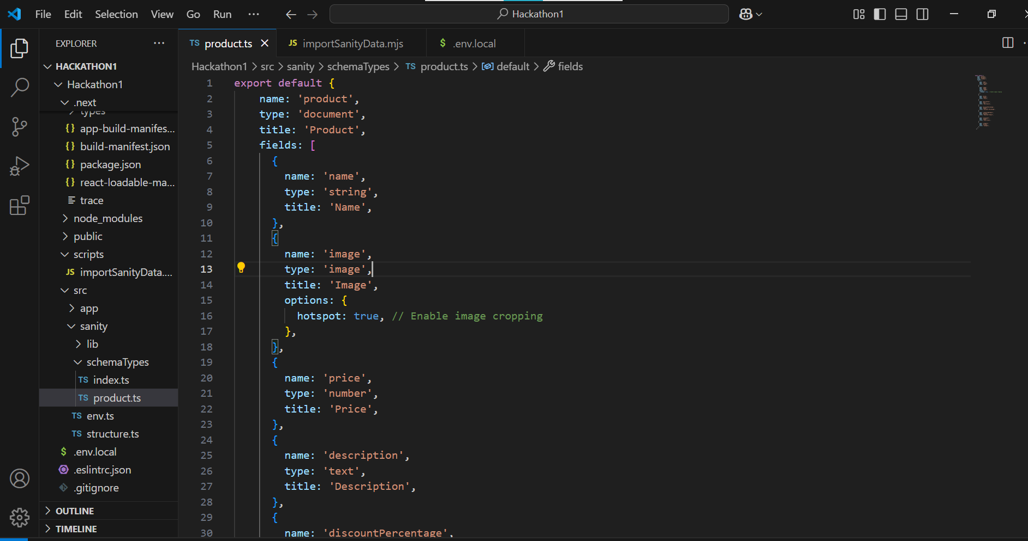

I have created a scripts folder and an importSanityData.mjs file within it. This file contains the code to upload products from an external API to Sanity, including image uploads. The script utilizes the @sanity/client and node-fetch to interact with the Sanity API and handle the data migration.

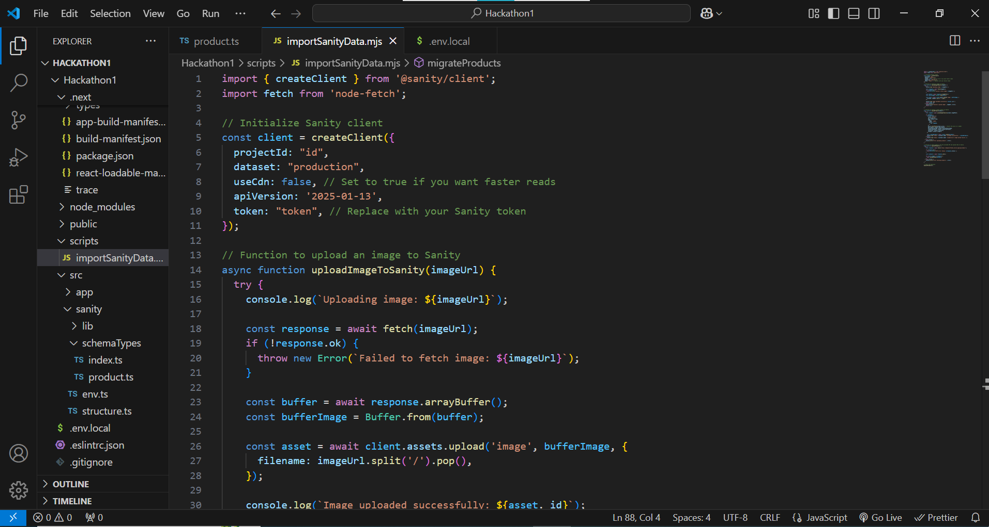

The "import-data" script is added to the scripts section of your package.json file. It runs the importSanityData.mjs file located in the scripts folder using Node.js. This script is responsible for importing product data into your Sanity project.

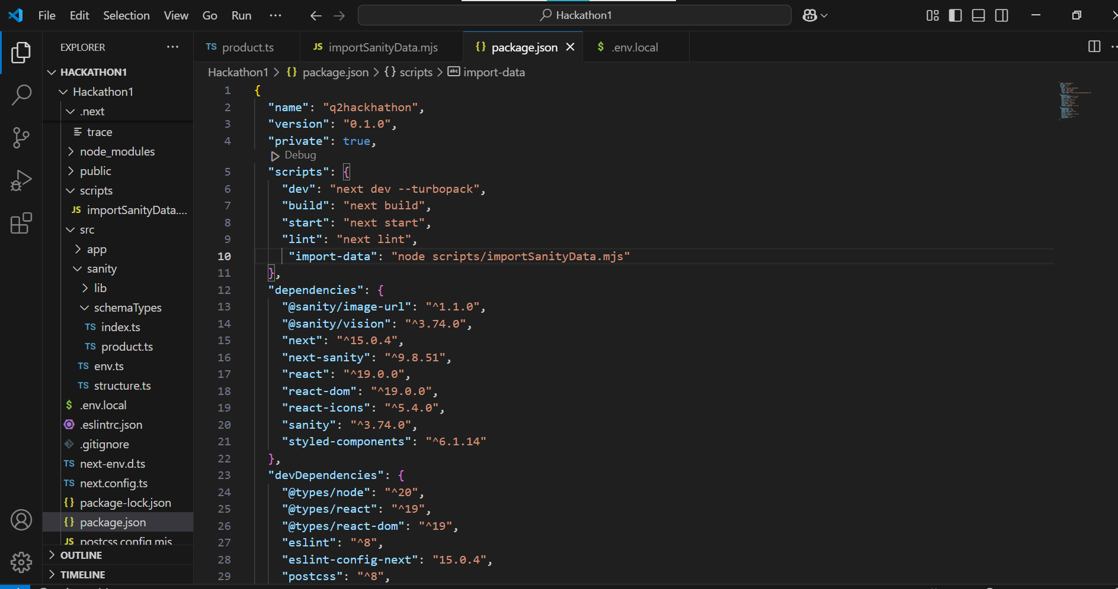

You have imported the product data type into your index.js file, allowing you to work with and manage product data in your Sanity project.

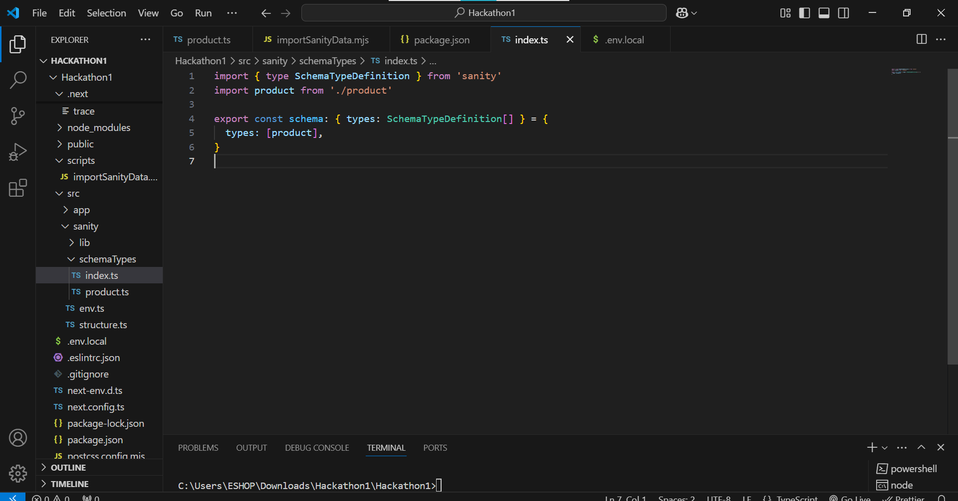

**Run Command,**

**npm run import-data**

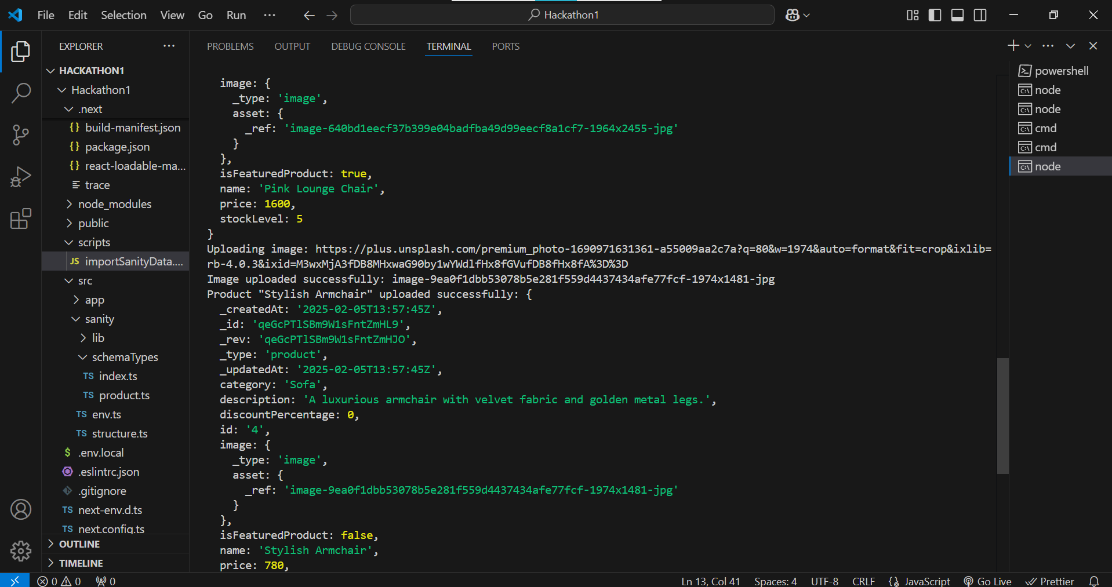

The product data has successfully appeared in Sanity after running the local studio. This means the data was correctly uploaded and is now available in your Sanity Studio for further management and editing.

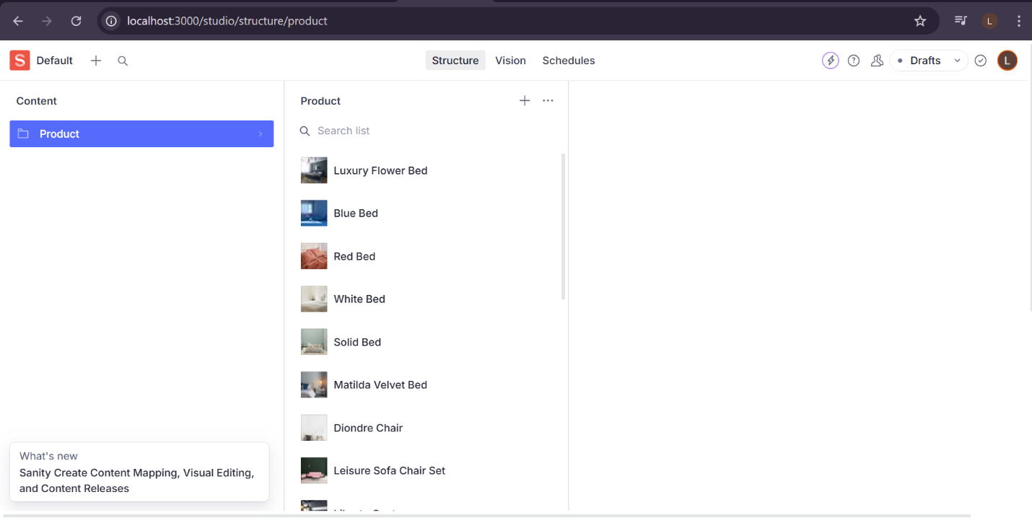

**Successfully Completed Day 3**